**САНКТ-ПЕТЕРБУРГСКИЙ ГОСУДАРСТВЕННЫЙ ПОЛИТЕХНИЧЕСКИЙ УНИВЕРСИТЕТ**

**Институт компьютерных наук и технологий**

**Кафедра Компьютерных Систем и Программных Технологий**

**Отчет по дисциплине**

**«Базы данных»**

**Язык SQL-DDL**

**Работу выполнил студент группы №:** 43501/3 Иванов И. М.

**Работу принял преподаватель:** ______________ Мяснов А.В.

**Санкт-Петербург**

**2016 г.**

## Цели работы:

## Познакомить студентов с основами проектирования схемы БД, способами нормализации отношений в БД.

## Программа работы

1. Представить SQL-схему БД, соответствующую заданию (должно получиться не менее 7 таблиц)
2. Привести схему БД к [3НФ](http://ru.wikipedia.org/wiki/%D0%A2%D1%80%D0%B5%D1%82%D1%8C%D1%8F_%D0%BD%D0%BE%D1%80%D0%BC%D0%B0%D0%BB%D1%8C%D0%BD%D0%B0%D1%8F_%D1%84%D0%BE%D1%80%D0%BC%D0%B0)
3. Согласовать с преподавателем схему БД. Обосновать соответствие схемы [3НФ](http://ru.wikipedia.org/wiki/%D0%A2%D1%80%D0%B5%D1%82%D1%8C%D1%8F_%D0%BD%D0%BE%D1%80%D0%BC%D0%B0%D0%BB%D1%8C%D0%BD%D0%B0%D1%8F_%D1%84%D0%BE%D1%80%D0%BC%D0%B0).
4. Продемонстрировать результаты преподавателю

**Ход работы:**

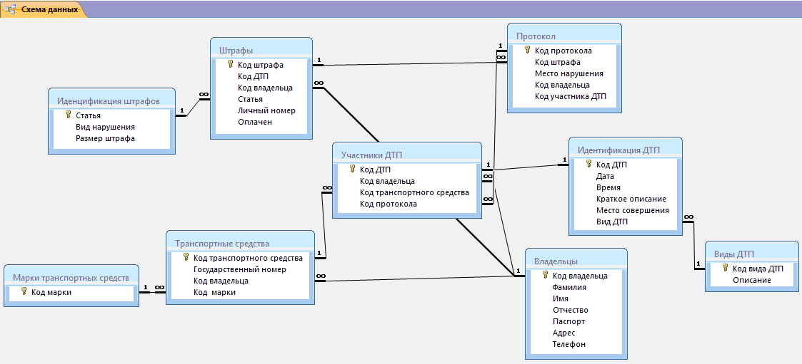

Рисунок 1. Схема базы данных

|  |
| --- |
| SET SQL DIALECT 3;  SET NAMES WIN1251;  SET CLIENTLIB 'C:\Program Files (x86)\Firebird\Firebird_3_0\fbclient.dll';  CREATE DATABASE 'C:\7semestr\database\MYONE.FDB'  USER 'SYSDBA' PASSWORD 'masterkey'  PAGE_SIZE 16384  DEFAULT CHARACTER SET WIN1251 COLLATION WIN1251;  CREATE TABLE ACCIDENT_PARTICIPANT (  DTP_CODE INTEGER NOT NULL,  OWNERS_CODE INTEGER NOT NULL,  VEHICLE_CODE INTEGER NOT NULL,  PROTOCOL_CODE INTEGER NOT NULL  );  CREATE TABLE FINES (  FINE_CODE INTEGER NOT NULL,  DTP_CODE INTEGER NOT NULL,  OWNERS_CODE INTEGER NOT NULL,  ARCTICLE INTEGER NOT NULL,  PERSONAL_NUMBER INTEGER NOT NULL,  PAID BOOLEAN NOT NULL  );  CREATE TABLE FINES_IDENTIFICATION (  ARTICLE INTEGER NOT NULL,  TYPE_OF_VIOLATION VARCHAR(256) NOT NULL,  PENALTY_RATE INTEGER NOT NULL  );  CREATE TABLE IDENTIFICATION_OF_ROAD_ACCIDENT (  DTP_CODE INTEGER NOT NULL,  "DATE" DATE NOT NULL,  "TIME" TIME NOT NULL,  SHORT_DESCRIPTION VARCHAR(10) NOT NULL,  PERFECT_PLACE VARCHAR(10) NOT NULL,  TYPE_OF_ACCIDENT_CODE INTEGER NOT NULL  );  CREATE TABLE MARK_VECHICLES (  THE_CODE_MARKS INTEGER NOT NULL,  MARK VARCHAR(30) NOT NULL  );  CREATE TABLE OWNERS (  SURNAME VARCHAR(30) NOT NULL,  NAME VARCHAR(30) NOT NULL,  MIDDLE_NAME VARCHAR(35) NOT NULL,  PASSPORT_NUMBER INTEGER NOT NULL,  ADDRESS VARCHAR(256) NOT NULL,  PHONE INTEGER NOT NULL,  OWNERS_CODE INTEGER NOT NULL  );  CREATE TABLE PROTOCOL (  PROTOCOL_CODE INTEGER NOT NULL,  FINE_CODE INTEGER NOT NULL,  VIOLATIONS VARCHAR(256) NOT NULL,  OWNERS_CODE INTEGER NOT NULL,  CODE_ACCIDENT INTEGER NOT NULL  );  CREATE TABLE TRANSPORTATION (  VEHICLE_CODE INTEGER NOT NULL,  GOVERNMENT_NUMBER VARCHAR(8) NOT NULL,  OWNERS_CODE INTEGER NOT NULL,  THE_CODE_MARKS INTEGER NOT NULL  );  CREATE TABLE TYPES_OF_ACCIDENT (  TYPE_OF_ACCIDENT_CODE INTEGER NOT NULL,  DESCRIPTION VARCHAR(256) NOT NULL  );  ALTER TABLE IDENTIFICATION_OF_ROAD_ACCIDENT ADD CONSTRAINT UNQ1_IDENTIFICATION_OF_ROAD_ACC UNIQUE (TYPE_OF_ACCIDENT_CODE);  ALTER TABLE FINES ADD CONSTRAINT PK_FINES PRIMARY KEY (FINE_CODE);  ALTER TABLE FINES_IDENTIFICATION ADD CONSTRAINT PK_FINES_IDENTIFICATION PRIMARY KEY (ARTICLE);  ALTER TABLE IDENTIFICATION_OF_ROAD_ACCIDENT ADD CONSTRAINT PK_IDENTIFICATION_OF_ROAD_ACCID PRIMARY KEY (DTP_CODE);  ALTER TABLE MARK_VECHICLES ADD CONSTRAINT PK_MARK_VECHICLES PRIMARY KEY (THE_CODE_MARKS);  ALTER TABLE OWNERS ADD CONSTRAINT PK_OWNERS PRIMARY KEY (OWNERS_CODE);  ALTER TABLE PROTOCOL ADD CONSTRAINT PK_PROTOCOL PRIMARY KEY (PROTOCOL_CODE);  ALTER TABLE TRANSPORTATION ADD CONSTRAINT PK_TRANSPORTATION PRIMARY KEY (VEHICLE_CODE);  ALTER TABLE TYPES_OF_ACCIDENT ADD CONSTRAINT PK_TYPES_OF_ACCIDENT PRIMARY KEY (TYPE_OF_ACCIDENT_CODE);  ALTER TABLE ACCIDENT_PARTICIPANT ADD CONSTRAINT FK_ACCIDENT_PARTICIPANT_1 FOREIGN KEY (VEHICLE_CODE) REFERENCES TRANSPORTATION (VEHICLE_CODE);  ALTER TABLE ACCIDENT_PARTICIPANT ADD CONSTRAINT FK_ACCIDENT_PARTICIPANT_2 FOREIGN KEY (OWNERS_CODE) REFERENCES OWNERS (OWNERS_CODE);  ALTER TABLE ACCIDENT_PARTICIPANT ADD CONSTRAINT FK_ACCIDENT_PARTICIPANT_3 FOREIGN KEY (DTP_CODE) REFERENCES IDENTIFICATION_OF_ROAD_ACCIDENT (DTP_CODE);  ALTER TABLE ACCIDENT_PARTICIPANT ADD CONSTRAINT FK_ACCIDENT_PARTICIPANT_4 FOREIGN KEY (PROTOCOL_CODE) REFERENCES PROTOCOL (PROTOCOL_CODE);  ALTER TABLE FINES ADD CONSTRAINT FK_FINES_1 FOREIGN KEY (ARCTICLE) REFERENCES FINES_IDENTIFICATION (ARTICLE);  ALTER TABLE FINES ADD CONSTRAINT FK_FINES_2 FOREIGN KEY (OWNERS_CODE) REFERENCES OWNERS (OWNERS_CODE);  ALTER TABLE IDENTIFICATION_OF_ROAD_ACCIDENT ADD CONSTRAINT FK_IDENTIFICATION_OF_ROAD_ACCID FOREIGN KEY (TYPE_OF_ACCIDENT_CODE) REFERENCES TYPES_OF_ACCIDENT (TYPE_OF_ACCIDENT_CODE);  ALTER TABLE PROTOCOL ADD CONSTRAINT FK_PROTOCOL_1 FOREIGN KEY (FINE_CODE) REFERENCES FINES (FINE_CODE);  ALTER TABLE TRANSPORTATION ADD CONSTRAINT FK_TRANSPORTATION_1 FOREIGN KEY (THE_CODE_MARKS) REFERENCES MARK_VECHICLES (THE_CODE_MARKS);  ALTER TABLE TRANSPORTATION ADD CONSTRAINT FK_TRANSPORTATION_2 FOREIGN KEY (OWNERS_CODE) REFERENCES OWNERS (OWNERS_CODE); |

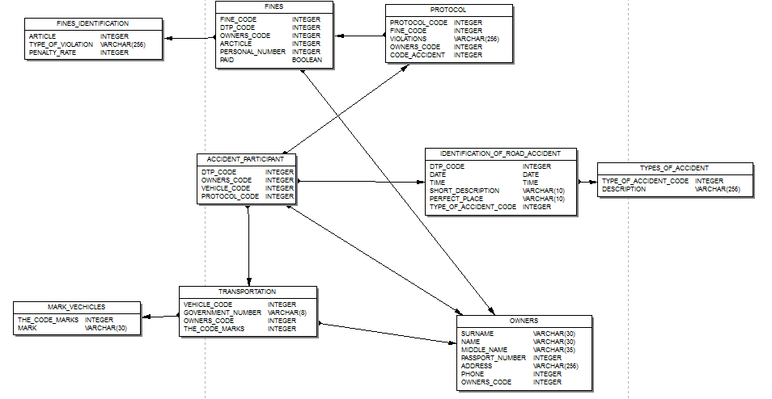

ER-диаграмма.

Изменим таблицу в соответствии с индивидуальным заданием.

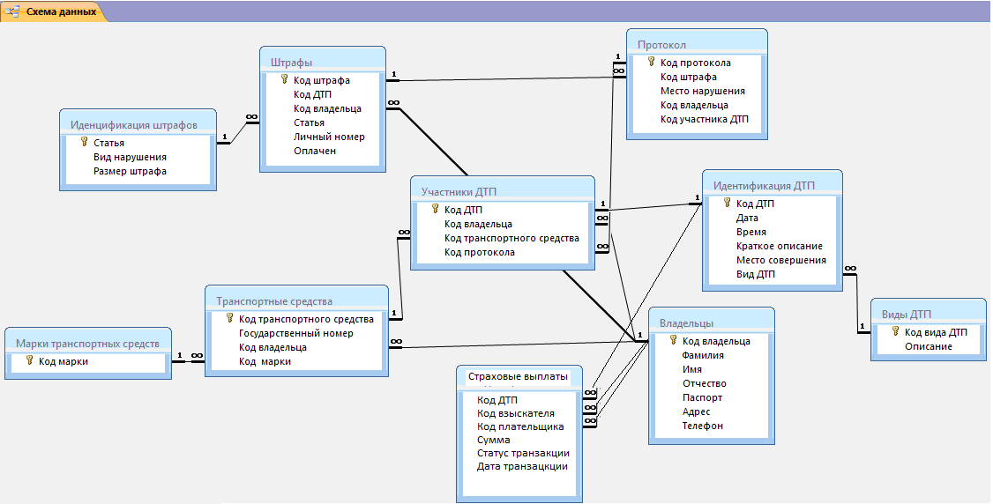

|  |
| --- |
| CREATE TABLE INSURANCE_PAYMENTS (  DTP_CODE INTEGER NOT NULL,  CREDITOR_CODE INTEGER NOT NULL,  PAYER_CODE INTEGER NOT NULL,  "SUM" INTEGER NOT NULL,  TRANSACTION_STATUS VARCHAR(30) NOT NULL,  DATE_OF_TRANSACTION DATE NOT NULL,  PAYER_CODE INTEGER NOT NULL  );  ALTER TABLE INSURANCE_PAYMENTS ADD CONSTRAINT FK_INSURANCE_PAYMENTS_1 FOREIGN KEY (CREDITOR_CODE) REFERENCES OWNERS (OWNERS_CODE);  ALTER TABLE INSURANCE_PAYMENTS ADD CONSTRAINT FK_INSURANCE_PAYMENTS_2 FOREIGN KEY (PAYER_CODE) REFERENCES OWNERS (OWNERS_CODE);  ALTER TABLE INSURANCE_PAYMENTS ADD CONSTRAINT FK_INSURANCE_PAYMENTS_3 FOREIGN KEY (DTP_CODE) REFERENCES IDENTIFICATION_OF_ROAD_ACCIDENT (DTP_CODE);  ALTER TABLE MARK_VECHICLES ADD MARK VARCHAR(30) NOT NULL; |

**ER-диаграмма:**

